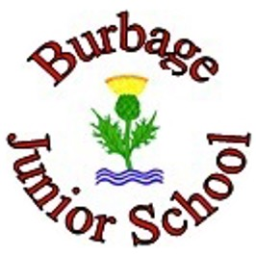

British Values Policy 2023-2026

Adopted by Burbage Junior School on | Autumn 2023
Next Review Due | Autumn 2026
Chair of Governors | Date:
Headteacher | Date:

Overview

At Burbage Junior School we aim for our children to become responsible and engaged citizens, who know they can actively participate in the democratic process and make choices about how the society they are a part of is organised. We want to encourage them to have a respect for authority, while also knowing they can have a voice in making key decisions that will impact upon their lives, and, later, choosing who their leaders are, and how they are led. We believe it is crucial that they develop a respect for diversity and a sense of how they, as individuals, can help to create a strong sense of community cohesion.

Our PSHCE curriculum lies at the heart of everything we do at school, in terms of how we nurture the basic principles of right and wrong, care for others (as well as ourselves), and learning to respect and embrace differences in a very diverse and modern Britain.
We plan lessons, particularly in PHSE and RE, to teach the children about our values, respecting similarities and differences, tackling stereotypes and understanding why some people discriminate. We aim to empower children to have a voice and to stand up against discrimination, valuing equality, tolerance and mutual respect.

Weekly assemblies are provided by Picture News, who reiterate and reinforce the British value embedded in that week’s session, as well as the protected characteristic it is relevant to.

British values are promoted throughout the school using our vision and values.
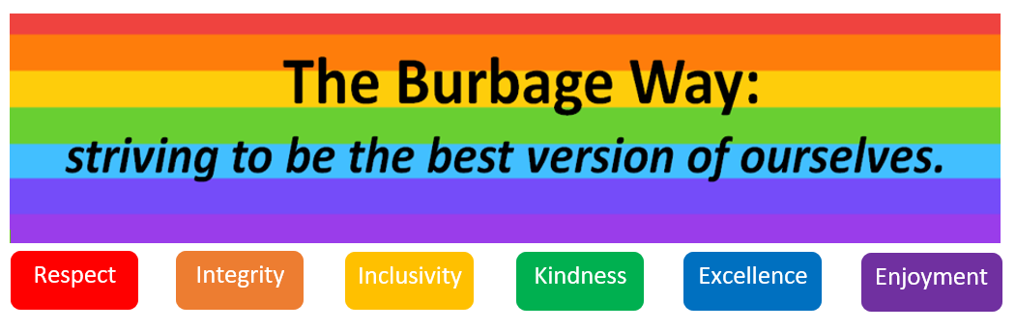

The themes and lessons in the school’s curriculum are designed carefully and planned by teachers to provide a rich learning experience that will have a positive impact on pupils’ spiritual, moral, social and cultural development.

Visits are planned to link with the class themes to provide children with further understanding of the world they live in. We also link with other schools to take part in sporting events. Competitions provide the opportunity for children to meet other children from different schools whilst experiencing the process of decision making and understanding rules and fairness.

As well as promoting British values we would actively challenge pupils, staff or parents expressing opinions contrary to fundamental British values, including ‘extremist’ views and principles.

Democracy
Each year the children decide upon their class charter and the rights associated with these. All the children contribute to the drawing up of the charter.

Democracy is evident across all puzzles within the Jigsaw PSHE programme. Children have lots of opportunities for their voices to be heard through whole class, group or paired discussions. The Jigsaw Learning Charter aims to ensure that all lessons establish a safe learning environment. The ‘ground rules’ of the Learning Charter invite children to sign and agree to try and stick to the rules during all Jigsaw lessons. It encourages children (and adults alike) to listen carefully to one another and respect the right of others whilst having opportunities to have their own opinions and voices heard. Jigsaw encourages children to take ownership of their learning through their ‘Help Me Reflect’ time when recording their thoughts, feelings and ideas in their individual Jigsaw Journals. Many of the Jigsaw PSHE lessons include ‘Pause for Thought’ moments, whereby children can reflect in the moment; considering their thoughts and feelings. Opportunities are given to all of the children to share their thinking, thoughts and ideas with others if they feel comfortable doing so.

Children have many opportunities for their voices to be heard. We have school councils which meet regularly to discuss issues raised in class. Council members for each year group are voted in by their class. They work closely with the school’s leadership team as part of working groups called Curriculum Champions, Attitude Ambassadors and Well-being Warriors.

Children are regularly invited to complete questionnaires to put forward their views about their school.

The Rule of Law
The importance of Laws, whether they be those that govern the class, the school, or the country, are consistently reinforced throughout regular school days, as well as when dealing with behaviour and through school assemblies.

Pupils are taught the value and reasons behind laws, that they govern and protect us, the responsibilities that this involves and the consequences when laws are broken.

Visits from authorities such as the Police and Fire Service help reinforce this message.

The Rule of Law is evident in every Jigsaw PSHE lesson when beginning the session with the Jigsaw Learning Charter. Establishing a safe, comfortable environment for all children (and adults) to learn in is paramount to every lesson. Children are also taught about their rights as a child, including those from The United Nations Convention on the Rights of the Child (UNCRC). These are included in all puzzle pieces. At Jigsaw, we believe it is important for children to understand equality and their rights, to understand how both they should be treated, and how they should treat others. Children are taught the value, importance and reasoning behind why rules exist. There are lots of opportunities throughout all age groups to explore making positive choices as well as how this balances with consequences. Making positive behavioural choices is explored through class, partner and group discussions.
This is reinforced by our Behaviour policy which provides clear rules and consequences of unwanted actions as well as the chance for pupils to ‘put it right’.

Individual Liberty
Within our school, pupils are actively encouraged to make choices, knowing that they are in a safe and supportive environment.

Through outdoor learning and school visits and residentials, we educate and provide boundaries for young pupils to make choices, through a safe environment and empowering education.

Pupils are encouraged to know, understand and exercise their rights and personal freedoms and advised how to exercise these safely, for example through our E- Safety and PSHE/RSE lessons.

Jigsaw provides a structured programme of personal development to nurture the ‘whole child’ and increase learning capacity, underpinned by mindfulness philosophy and practice. Jigsaw PSHE begins this teaching right from the beginning and offers opportunities for children’s spiritual, moral, social and cultural (SMSC) development. Children are provided with opportunities to make informed choices and feel comfortable expressing their views. The ethos of a Jigsaw lesson aims to always make every child feel welcomed, valued and comfortable and therefore promotes a positive learning environment.

Mutual Respect
Mutual respect is at the heart of our values. Children learn that their behaviours have an effect on their own lives and those of others. All members of the school community are expected to treat each other with respect. This is one of Burbage Junior School’s core values.

Respect is a key aspect of learning in PSHE sessions, using Jigsaw. This enables and teaches children to have respectful discussions on sensitive subjects. Jigsaw aims to provide a structured lesson format in which a safe learning environment is created. Each lesson plan includes phrasing, suggested use of language and terminology as well as suggestions for asking open-ended questions sensitively and reflectively. Jigsaw lesson plans provide these prompts through ‘ask me this’ questions. These are designed to support adults leading the session to feel confident in connecting with children to think about how they feel or what their opinions/ideas may be. Often this includes topics which involve thought-provoking and sensitive subjects. As children get older they build on previous knowledge and skills to develop their ability to listen to others respectfully, debate other people’s views and consider ways that we can be accepting of those who may be different to ourselves. Even in lessons where different points of view are encouraged, and issues may be debated, the Learning Charter is always revisited and its expectations reinforced. This ensures that children feel enabled to freely express their faith, feelings and values in an environment of mutual respect.

Tolerance – of those of different faiths and beliefs
Burbage Junior School places a great emphasis on promoting diversity with the children.

Children visit places of worship that are important to different faiths annually, as part of their RE lessons. Members of different faiths or religions are encouraged to share their knowledge to enhance learning within classes and the school.

In PSHE lessons, the Celebrating Difference puzzle specifically looks at how we might differ in many ways, but that there are human and spiritual elements in us all where we can find a connection and empathy with each other, no matter how much the world might find difference a cause for conflict. Jigsaw aims to go beyond ‘tolerance’ to help children ‘celebrate difference’, their own individuality and that of others. The children learn to be interested in what makes us all unique and this includes the way we embody our beliefs, feelings and values. Elements of the Equality Act are examined within this puzzle which again ensures that the faiths, feelings and values of others are respected.

The school values of respect and inclusivity ensures that children understand that the respect we discuss in Jigsaw PSHE permeates into other areas of school life and supports schools in ensuring that all differences in faith and beliefs are celebrated and respected.

Weekly picture news assemblies reinforce protected characteristics so pupils remember that we all have the right to be treated fairly no matter what our differences.

Equality Statement
The school’s Equality Statement makes explicit our desire to show respect to all members of our school community irrespective of their race, religion, colour, sex or social class. We are opposed to racism in all its manifestations.

We aim to promote awareness of what all human beings have in common and to discourage negative attitudes towards others.

This awareness is promoted both through the curriculum and through the attitudes which we try to foster in the day-to-day life of the school community.

